S2. The productive performance of pigs included in the study
Table. S2.1 Comparation of health, sexual maturity and farrow from 20 sows included at the beginning of the study, treatment A (TA) for animals with antimicrobial supplements in feed and treatment B (TB) for animals feeding without antimicrobial supplements.

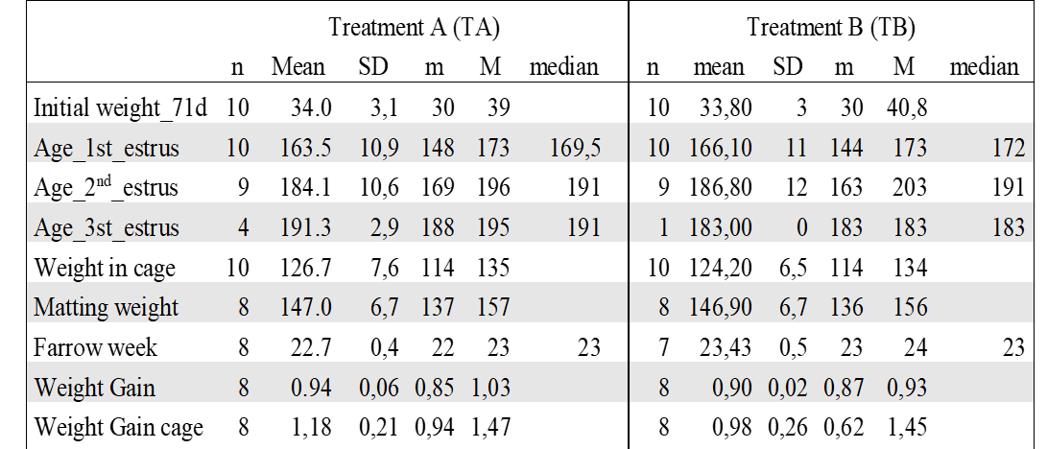

Table S2.2 From 20 sows included at the beginning of the study, 7 farrowed at the same period of time, and their offspring were selected to complete the experimental pens respecting the treatment groups. Treatment A (TA) for animals with antimicrobial supplements in feed and treatment B (TB) for animals feeding without antimicrobial supplements.
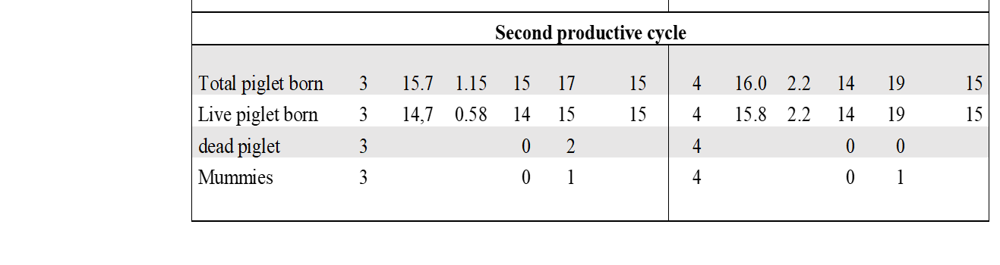

Gender | Treatment A (TA) |  |  |  | Treatment B (TB)
Gender | n | weight | carcass | Performance (%) | n | weight | carcass | Performance (%)
1 | 27 | 133,06 | 108,93 | 81,87 | 20 | 130,0 | 105,0 | 80,76
2 | 13 | 149,03 | 118,42 | 79,46 | 19 | 141,05 | 112,9 | 80,04
Total | 40 | 141,05 | 113,68 | 80,59 | 39 | 135,53 | 108,95 | 80,39
Table S2.3 Productive performance of pigs after slaughtering at 170 days. A sample of 79 pigs were taken (40 from treatment A and 39 from treatment B). Pigs were separated as male (1) pigs and female (2). There were not significative differences in the productive performance. One Treatment B pig die during the study by hearth attack.

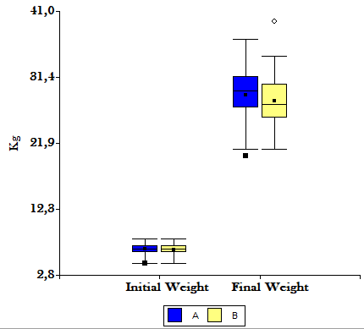

Figure S2.4 Figure showing weight comparation between piglets (n=40) from treatment group A (blue boxes) that were feed with antimicrobial supplements and piglets (n=40) in group B (yellow boxes) that were feed without antimicrobials. There were not significative differences in weight of piglets. Initial weight was taken at 21d and final weight was taken at 70d.

